LABORATORIYA ISHI №4
Mavzu: PHP orqali MySQL ma’lumotlar bazasiga ulanish
1. Ishning maqsadi
- Tayyor MySQL bazaga PHP orqali ulanish
- SELECT so‘rovlarini bajarish
- INNER JOIN orqali bir nechta jadval ma’lumotlarini chiqarish
- MySQLi (procedural, OOP) va PDO usullarini taqqoslash
- Ular orasidagi farqlarni amaliy ko‘rsatish
2. Nazariy qism
PHP orqali MySQL bilan ishlashning 3 asosiy usuli mavjud:
- MySQLi (Procedural)
- MySQLi (Object-Oriented)
- PDO (PHP Data Objects)


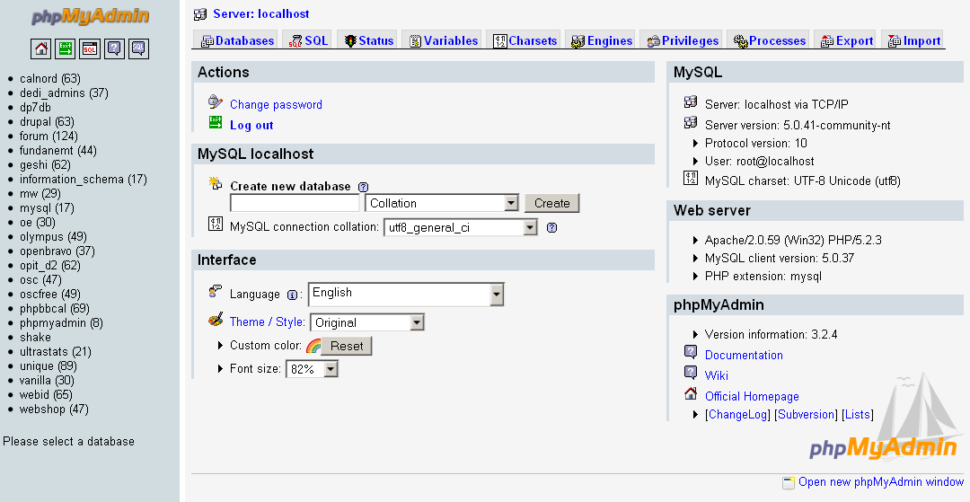

3. Amaliy baza (tayyor database)
Database: db_universitet
3 ta jadval:
fakultetlar
- id (PK)
- nomi
talabalar
- id (PK)
- ism
- kurs
- fakultet_id (FK)
fanlar
- id (PK)
- fan_nomi
- kredit
- talaba_id (FK)
4. Oddiy SELECT so‘rovi
SELECT * FROM talabalar;
5. JOIN so‘rovi
SELECT
talabalar.ism,
talabalar.kurs,
fakultetlar.nomi AS fakultet,
fanlar.fan_nomi
FROM talabalar
INNER JOIN fakultetlar ON talabalar.fakultet_id = fakultetlar.id
INNER JOIN fanlar ON talabalar.id = fanlar.talaba_id;
6. PHP orqali ulanish usullari
6.1 MySQLi – Procedural usul
<?php
$conn = mysqli_connect("localhost", "root", "", "db_universitet");
if (!$conn) {
die("Ulanish xatoligi: " . mysqli_connect_error());
}
$sql = "SELECT * FROM talabalar";
$result = mysqli_query($conn, $sql);
while ($row = mysqli_fetch_assoc($result)) {
echo $row['ism'] . " - " . $row['kurs'] . "<br>";
}
mysqli_close($conn);
?>
Xususiyatlari:
- Oddiy
- Faqat MySQL bilan ishlaydi
- Xavfsizlik PDO ga qaraganda pastroq
6.2 MySQLi – Object Oriented usul
<?php
$conn = new mysqli("localhost", "root", "", "db_universitet");
if ($conn->connect_error) {
die("Xatolik: " . $conn->connect_error);
}
$sql = "SELECT * FROM talabalar";
$result = $conn->query($sql);
while ($row = $result->fetch_assoc()) {
echo $row['ism'] . "<br>";
}
$conn->close();
?>
Xususiyatlari:
- OOP yondashuv
- Professionalroq
- Katta loyihalar uchun qulay
6.3 PDO usuli (Tavsiya etiladi)
<?php
try {
$conn = new PDO("mysql:host=localhost;dbname=db_universitet", "root", "");
$conn->setAttribute(PDO::ATTR_ERRMODE, PDO::ERRMODE_EXCEPTION);
$sql = "SELECT * FROM talabalar";
$stmt = $conn->query($sql);
while ($row = $stmt->fetch(PDO::FETCH_ASSOC)) {
echo $row['ism'] . "<br>";
}
} catch(PDOException $e) {
echo "Xatolik: " . $e->getMessage();
}
?>
Xususiyatlari:
- Turli DB lar bilan ishlaydi (MySQL, PostgreSQL, Oracle)
- Eng xavfsiz
- Prepared Statement kuchli
- try-catch bilan ishlaydi
7. PDO orqali JOIN misoli
<?php
try {
$conn = new PDO("mysql:host=localhost;dbname=db_universitet", "root", "");
$conn->setAttribute(PDO::ATTR_ERRMODE, PDO::ERRMODE_EXCEPTION);
$sql = "SELECT
talabalar.ism,
talabalar.kurs,
fakultetlar.nomi AS fakultet,
fanlar.fan_nomi
FROM talabalar
INNER JOIN fakultetlar
ON talabalar.fakultet_id = fakultetlar.id
INNER JOIN fanlar
ON talabalar.id = fanlar.talaba_id";
$stmt = $conn->query($sql);
echo "<table border='1'>";
echo "<tr><th>Ism</th><th>Kurs</th><th>Fakultet</th><th>Fan</th></tr>";
while ($row = $stmt->fetch(PDO::FETCH_ASSOC)) {
echo "<tr>
<td>{$row['ism']}</td>
<td>{$row['kurs']}</td>
<td>{$row['fakultet']}</td>
<td>{$row['fan_nomi']}</td>
</tr>";
}
echo "</table>";
} catch(PDOException $e) {
echo "Xatolik: " . $e->getMessage();
}
?>
8. Usullarni taqqoslash
Xususiyat | MySQLi Procedural | MySQLi OOP | PDO
DB turi | Faqat MySQL | Faqat MySQL | Ko‘p DB
Xavfsizlik | O‘rtacha | Yaxshi | Eng yaxshi
try-catch | Yo‘q | Yo‘q | Bor
Prepared | Bor | Bor | Juda kuchli
Professional | O‘rtacha | Yaxshi | Eng yaxshi

9. Natija
Laboratoriya ishida:
- Tayyor MySQL bazaga ulanish amalga oshirildi
- SELECT so‘rovi bajarildi
- INNER JOIN ishlatildi
- 3 xil PHP usuli taqqoslandi
- PDO eng tavsiya etiladigan usul ekanligi ko‘rsatildi
Topshiriqlar:
Sug‘urta kompaniya
Database: db_sugurta
Jadvallar:
mijozlar
- id
- ism
polislar
- id
- turi
- mijoz_id (FK)
tolovlar
- id
- polis_id (FK)
- summa
JOIN vazifa:
Mijoz + Polis turi + To‘lov summasi chiqarish.
Talaba nima qiladi?
- Polis → mijoz
- To‘lov → polis
- JOIN orqali 3 jadvalni bog‘laydi
Kod qismi:
<?php
session_start();
if (!isset($_SESSION['mijozlar'])) {
$_SESSION['mijozlar'] = [];
$_SESSION['polislar'] = [];
$_SESSION['tolovlar'] = [];
}
if (isset($_POST['add'])) {
$mijoz_id = count($_SESSION['mijozlar']) + 1;
$polis_id = count($_SESSION['polislar']) + 1;
$tolov_id = count($_SESSION['tolovlar']) + 1;
$_SESSION['mijozlar'][] = [
"id" => $mijoz_id,
"ism" => $_POST['ism']
];
$_SESSION['polislar'][] = [
"id" => $polis_id,
"turi" => $_POST['turi'],
"mijoz_id" => $mijoz_id
];
$_SESSION['tolovlar'][] = [
"id" => $tolov_id,
"polis_id" => $polis_id,
"summa" => $_POST['summa']
];
}
$natija = [];
foreach ($_SESSION['mijozlar'] as $m) {
foreach ($_SESSION['polislar'] as $p) {
if ($m["id"] == $p["mijoz_id"]) {
foreach ($_SESSION['tolovlar'] as $t) {
if ($p["id"] == $t["polis_id"]) {
$natija[] = [
"mijoz" => $m["ism"],
"polis" => $p["turi"],
"summa" => $t["summa"]
];
}
}
}
}
}
?>
<!DOCTYPE html>
<html lang="uz">
<head>
<meta charset="UTF-8">
<meta name="viewport" content="width=device-width, initial-scale=1">
<title>Sug'urta Tizimi</title>
<link href="https://cdn.jsdelivr.net/npm/bootstrap@5.3.2/dist/css/bootstrap.min.css" rel="stylesheet">
<style>
body{
background: linear-gradient(135deg,#141e30,#243b55);
color:white;
}
.glass{
background: rgba(255,255,255,0.1);
backdrop-filter: blur(10px);
border-radius:20px;
box-shadow:0 15px 35px rgba(0,0,0,0.4);
}
.btn-modern{
background: linear-gradient(45deg,#00c6ff,#0072ff);
border:none;
color:white;
}
.btn-modern:hover{
opacity:0.85;
}
.table{
border-radius:15px;
overflow:hidden;
}
</style>
</head>
<body>
<div class="container py-5">
<h1 class="text-center mb-5">💼 Sug'urta Tizimi</h1>
<div class="glass p-4 mb-5">
<h4 class="mb-4">➕ Yangi Ma’lumot Qo‘shish</h4>
<form method="POST">
<div class="row g-3">
<div class="col-md-4">
<input type="text" name="ism" class="form-control" placeholder="Mijoz ismi" required>
</div>
<div class="col-md-4">
<select name="turi" class="form-select" required>
<option value="">Polis turini tanlang</option>
<option>Avto sug'urta</option>
<option>Hayot sug'urtasi</option>
<option>Uy sug'urtasi</option>
</select>
</div>
<div class="col-md-4">
<input type="number" name="summa" class="form-control" placeholder="To'lov summasi" required>
</div>
</div>
<button type="submit" name="add" class="btn btn-modern w-100 mt-4">
Qo‘shish
</button>
</form>
</div>
<div class="glass p-4">

<h4 class="mb-4">📊 Mijoz + Polis + To‘lov </h4>
<div class="table-responsive">
<table class="table table-striped table-bordered bg-white text-center align-middle">
<thead class="table-dark">
<tr>
<th>Mijoz</th>
<th>Polis turi</th>
<th>To‘lov summasi</th>
</tr>
</thead>
<tbody>
<?php if(empty($natija)): ?>
<tr>
<td colspan="3">Hozircha ma’lumot yo‘q</td>
</tr>
<?php else: ?>
<?php foreach ($natija as $row): ?>
<tr>
<td><?= htmlspecialchars($row["mijoz"]) ?></td>
<td><?= htmlspecialchars($row["polis"]) ?></td>
<td><strong><?= number_format($row["summa"]) ?> so'm</strong></td>
</tr>
<?php endforeach; ?>
<?php endif; ?>
</tbody>
</table>
</div>
</div>
</div>
</body>
</html>
Natija qismi:

